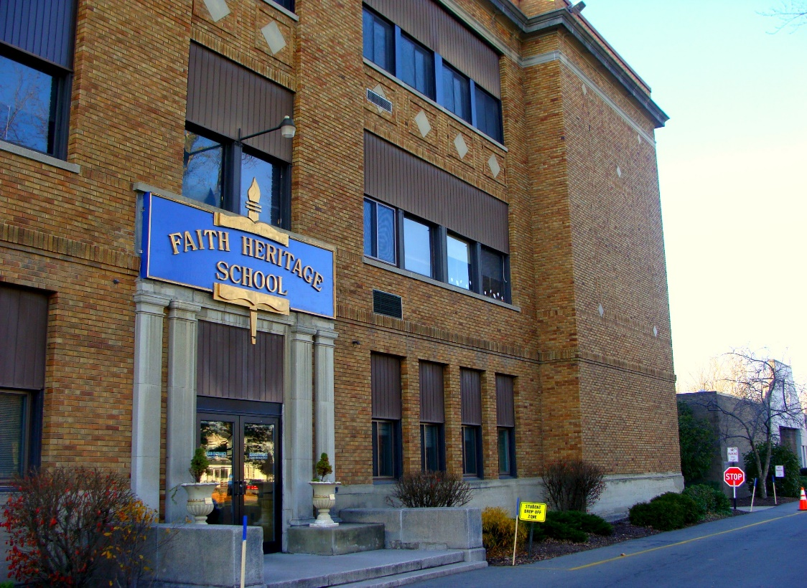

MINIMUM CAPACITY :-

The Minumum intake capacity

of students is between 350-620

children

LIBRARY :-

The Libarary is Available.

CANTEEN:-

The Canteen Facility is Available.

BOARDING :-

No availablility of boarding.

SPORTS :-

There are different categories

sports available.

Girls Volleyball

Boys Volleyball

Football

|  |  |  |
| --- | --- | --- |
| FAITH HERITAGE SCHOOL SYRACUSE - SCHOOL |  |  |
|  |  |  |
| School Detail :- Faith Heritage School is a private, non-denominational Christian, K-12 school in Syracuse, New York that was established in 1972. As of the 2003–2004 school year, its total enrollment was 557, with a student-to-teacher ratio of 14.3, according to NCES figures provided by the United States Department of Education.  Faith Heritage School exists to glorify God by providing a sound, Biblically integrated program in order to assist parents and churches in equipping students for Christian living and service within today’s changing world.  Students are becoming lovers of God who experience a close relationship with Jesus Christ, seeking above all things to Glorify His name and look forward to His coming |  |
|